|  |
| --- |
| Capstone |
| MERRIMACK COLLEGE |

IR Touch Screen Interface for Smart Mirrors

EEN4970A

Design Project II

Kyle Skey

Revision D

Revision Date: January 30, 2017

Revision History

|  |  |  |  |
| --- | --- | --- | --- |
| Revision | Date | Author | Notes |
| 0 | 09/12/2016 | K. Skey | Document Creation |
| A | 09/19/2016 | K. Skey | Added Specs Section to Market Assessment  Added High and Low Level Block Diagrams  Added Prelim Tx Array Schematic  Added Tx/Rx Sensitivity Section  Updated BOM |
| B | 09/26/2016 | K. Skey | Changed power supply specs from 5V to 3.3V  Added PCB Layout for Demo-Day Board |
| C | 12/6/2016 | K. Skey | Added Schematics  Added PC Layouts for Tx/Rx Boards  Removed Demo-Day Board  Removed LTSpice Schematic  Removed Rx/Tx Sensitivity |

# Market Assessment

## Introduction

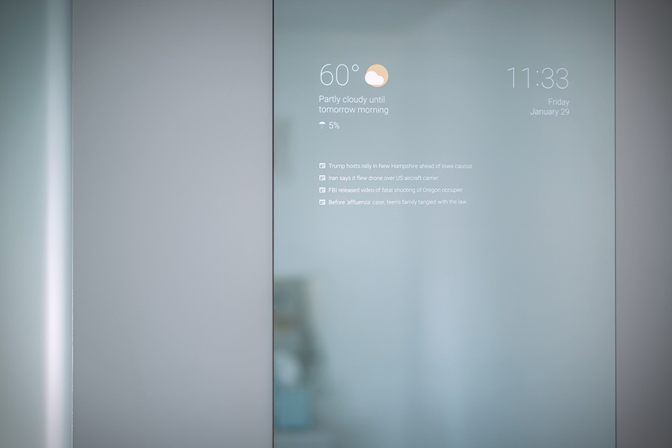In recent years, the Internet of Things (IoT) market has been expanding, as Wi-Fi speeds increase and embedded processing modules decrease in size and become more affordable. One such product that has immerged from this technology trend is the smart mirror (Figure 1). The most basic of smart mirrors involves placing a 2-way acrylic mirror on top of a computer or TV display. While keeping the background black, any light colored text will emit though the mirror glass and be seen on the user side. While this implementation is novel at best, it lacks customization and usability from someone who knows little or no programming.

Figure : Example Basic Smart Mirror

The biggest problem with the hobbyist smart mirror is it has no user interface; there is no easy way for the user to interact with it. To remedy this, an IR touch screen interface can be installed into the frame of the mirror. The IR touch screen interface can be sold as a kit for hobbyists to install their own custom sized interface, or integrated into a smart mirror product. With the accompaniment of software and application development, users of the smart mirror could be able to type text, load marketplace applications (Android, Apple, etc.), and customize their smart mirror to display information relevant to them.

## Specifications

* Resizable range (active area): Up to 52” x 29” (60” Display)
* Maximum resolution = 4096 x 4096
* Response time: 50-60 rps (response per second).
* Operating temperature: 0 to 70 degree C.
* Interface: USB 1.1 or higher.
* Power: 3.3VDC, 500 mA (power supply included).
* Operating system: Windows 7, 8,10 & Linux
* Driver: Linux/Windows mouse emulation.

# Technical Assessment

## Touch Screen Overview

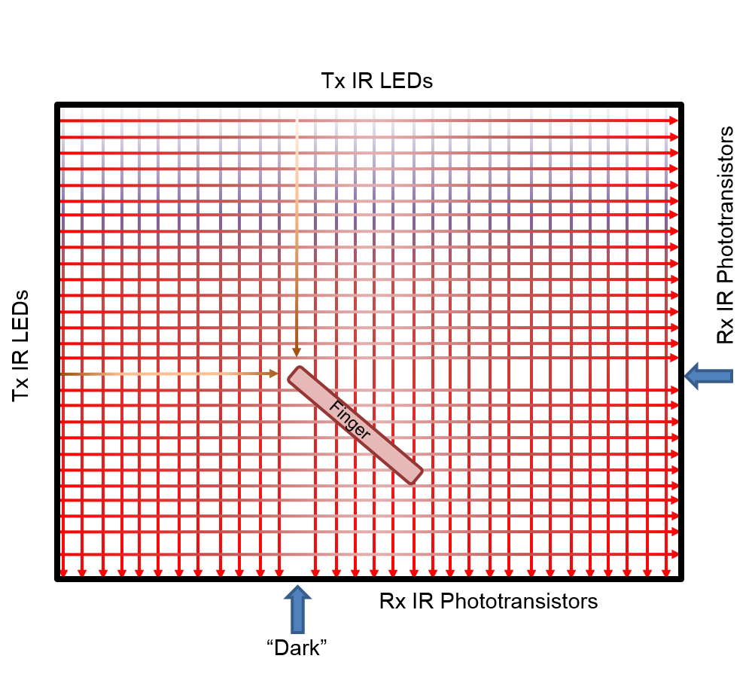There are two mainstream techniques for touch screen construction, capacitive and infrared (IR). While the capacitive touch screen is more desirable in terms of form-factor, its implementation on such a large of scale is difficult and expensive. Therefore, the touch screen will be developed using a grid of IR transmitters and receivers. IR LED transmitters will be placed in one horizontal and vertical axis of the display, side by side. IR Phototransistor receivers will be placed opposite of the transmitters, one for each transmitter. This will create a grid of IR light in the horizontal and vertical axis of the display (Figure 2). When an object (preferably a finger) enters the grid, it will block the IR light from the receiver in the horizontal and vertical axis, resulting in a calculated coordinate of that object. This coordinate can then be sent to a computer as a “click” of a mouse at a certain location.

Figure : IR Grid Diagram

## IR Tx/Rx Circuits

In theory, it is a simple task to use one IR LED to illuminate one IR Phototransistor and turn that into a binary signal which gets read by a microprocessor. The challenge is having over 200 transmitter-receiver pairs properly aligned and all reading into the same processor. This large scale implementation presents many challenges in the design and fabrication process, which include the following:

* Power consumption – Each LED uses approx. 100mA per unit. 200 x 100mA x 3.3V = 66W!!!
* Interference – When trying to read a receiver, adjacent LEDs could provide illumination that set off a false negative
* I/O lines – Microprocessors do not have 200+ I/O lines and using multiple microprocessors is too expensive and tricky
* PCB Construction – In order to have a small form-factor, PCBs will be used to mount the LED Tx/Rx circuits. It will be costly to produce a PCB that is not standard size, especially if there are errors in the first iteration

Many of these challenges are solved by only illuminating one LED at a time and taking a reading only on its paired receiver. This will solve the power consumption and interference problems as only one light will be on at a time. To solve the I/O line problem the Tx/Rx units will have to be grouped in units of 8, using transistors, and chained together. These basic groups can be placed in larger groups of 3 or 4 and placed on a PCB. The PCBs are designed in such a way that they are serialized in their communication with the controller. This can be achieved numerous ways, but initial analysis shows the following chips to be the best course of action:

* 74HCT138 - 3-to-8-line decoder/demultiplexer – This will be used to toggle the Tx LEDs, one at a time, within the larger group of 8. The addressable inputs match that of the ADC tied to the receiver being read.
* 74HCT164 - 8-bit serial-in, parallel-out shift register – This will be used to toggle each group of 8. These chips will be daisy-chained from PCB to PCB so that the last valid high in the parallel-out will trigger a high in the serial-in for the next chip.

## Block Diagrams

### High Level

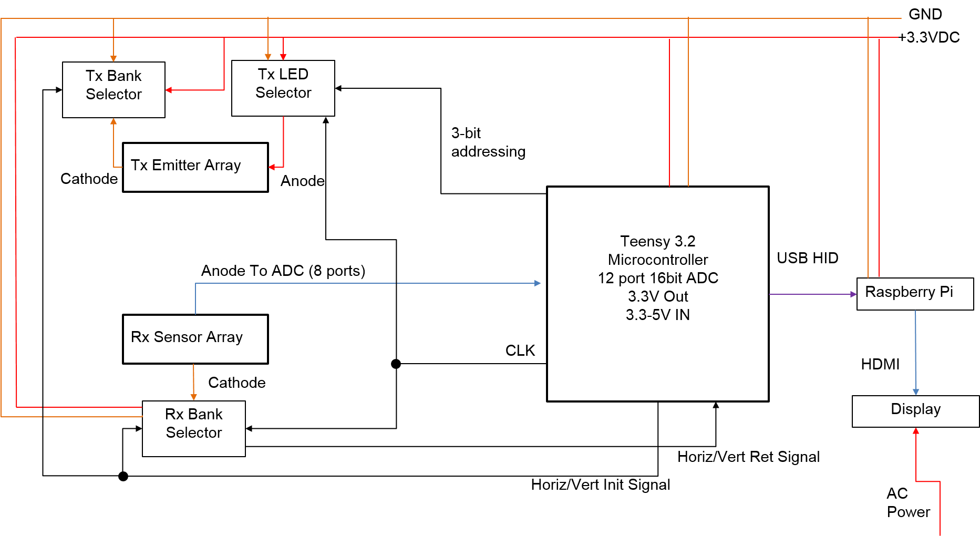

### Low Level Rx/Tx Config

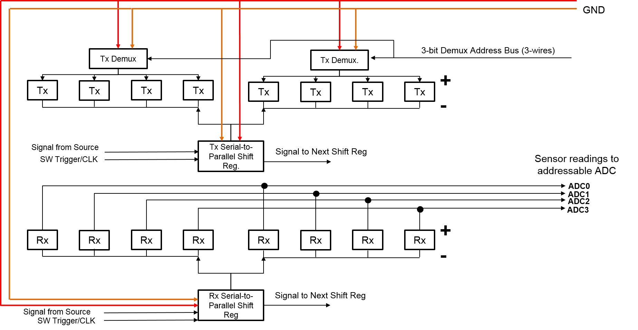

# Financial Assessment

The implementation of this design hinges on the completion of three key items, the Rx Board, the Tx Board, and the controller. Four corner boards, one containing the controller, will also be needed to link the Rx/Tx sections. In order to complete the project on schedule, the following phases will be implemented:

## Phase 1 – Rx/Tx Board Design and Fabrication

The schematics and PCB design, using ExpressSCH and ExpressPCB respectively, will be generated in parallel, which will take approx. 8 hrs to complete. The Design will be reviewed by Prof. Bowhers. 10 of each board will be ordered from ExpressPCB with silkscreen and solder mask, costing approx. $500, with 2 week lead time.

Total Labor: 10-12 hrs

Parts Cost: $500

## Phase 2 – Assembly and Test

Assembly of the boards will require two separate processes.